Traffic Management Policy
_________________________________________________________________________
1. Purpose
The purpose of this policy is to ensure the safe and efficient movement of vehicles and pedestrians within and around the school grounds during student drop-off, pick-up, and other school activities. The policy aims to reduce congestion, minimise risk, and provide clear expectations for families, staff, and visitors.

2. Scope
This policy applies to:
- All parents/carers and guardians dropping off or collecting students.
- Staff members using school car parks.
- Buses, contractors, and delivery vehicles accessing school grounds.
- Visitors attending the school.

3. Traffic Flow and Access
3.1 Entry and Exit
- Vehicles may enter via Starke Street or Hardwick Cres
- Right turns are not permitted when exiting the school. All vehicles must turn left to ensure steady traffic flow and minimise risk of collision.
3.2 Kiss-and-Ride Zone
- The blue-highlighted area is the designated Kiss-and-Ride Zone.
- This area is for immediate pick-up and drop-off only (no parking, waiting, or leaving vehicles unattended).
- Drivers must:
  - Stay in their vehicles.
  - Move forward when able to.
  - Ensure students enter/exit from the kerbside only.
3.3 Bus Zone
- The green marked bus stop zone is for buses only during operating hours.
- Parents/carers are not permitted to use the bus zone for drop-off or collection.
3.4 Staff Car Parks
- Staff car parks are for staff use only.
- Parents and visitors must not use staff car parks during drop-off and pick-up times.

4. Safety Rules
- Speed limit within school grounds: 10 km/h.
- Reversing in traffic flow areas is prohibited.
- Mobile phone use while driving in school grounds is strictly prohibited.
- Pedestrian crossings must be respected at all times.

5. Roles and Responsibilities
- School Leadership: oversee implementation, review, and communication of this policy.
- Parents/Carers: comply with traffic rules and model safe behaviour.
- Students: follow safe entry/exit practices and use crossings appropriately.

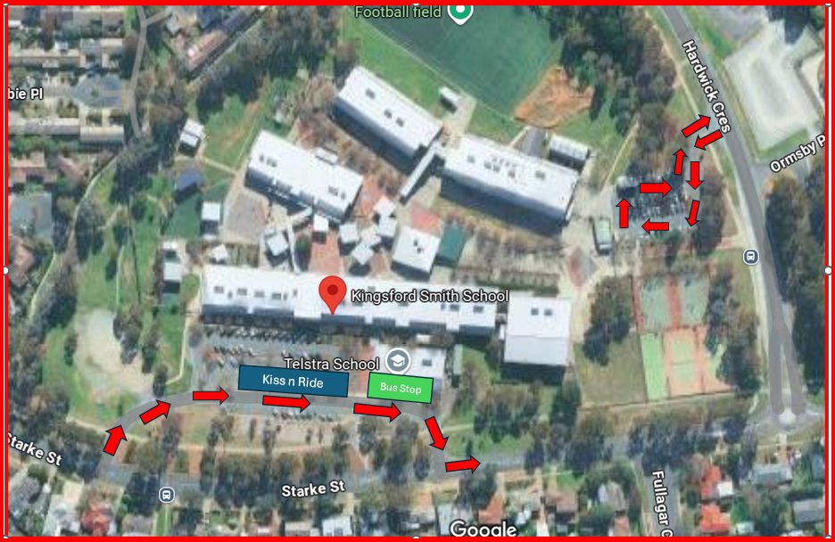

VERSION CONTROL
Version | Date | Author | Approved
1 | 16/09/2025 | Donna Attwood

